**Pandas**

* Stands for Python Data Analysis Library
* Multi-dimensional structured data sets
* Like a database query (SQL), CSV file
* It takes data & creates a Python object with row & columns called Data Frame that looks similar to table

**DataFrame:**

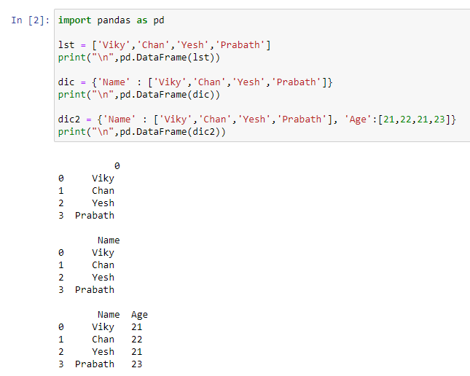

**Column Rename:**

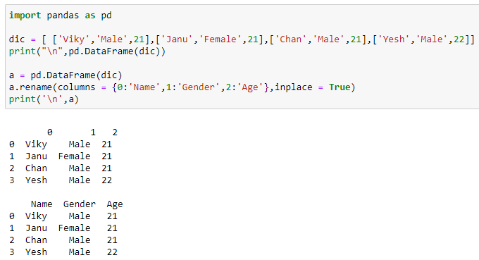

**CSV file : Column add**

